**Introduction**

Authentication Filter is a new feature in MVC 5 this filter run before any other filter, this filter is used to authenticate User which was not there in older version [MVC 4] there we were using Authorization filter or Action filter to Authenticate User, now new updated of MVC 5 this cool feature is available.

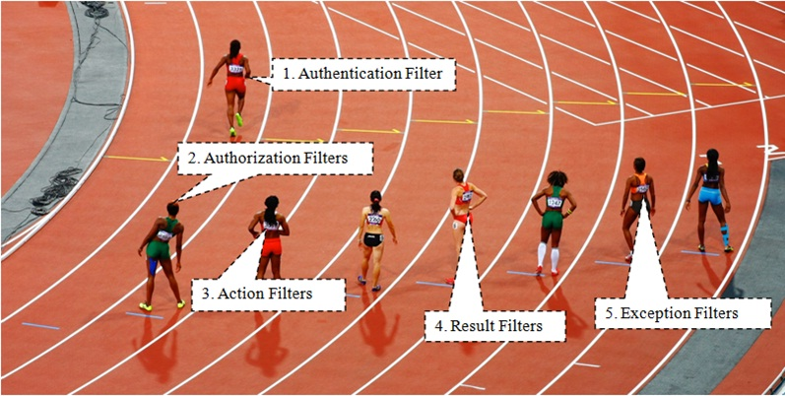

For Create Custom Authentication filter we need to inherit **IAuthenticationFilter** Interface.

**This interface has 2 methods**

1. OnAuthentication
2. OnAuthenticationChallenge

**OnAuthentication: -** In this method we are going to Authenticates the request.

**OnAuthenticationChallenge: -** this Method gets called when Authentication or Authorization is failed and this method is called after Execution of Action Method but before rendering of View.

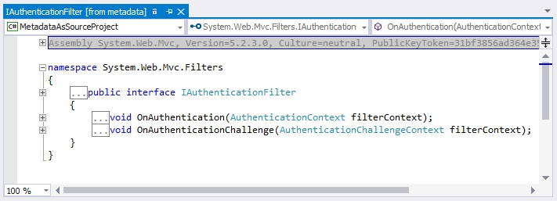

After understanding what is Authentication Filter let's create a project and see demo.

**Create New Asp.Net MVC Application**

From Visual studio 2015 IDE Start page click on "New Project" link.

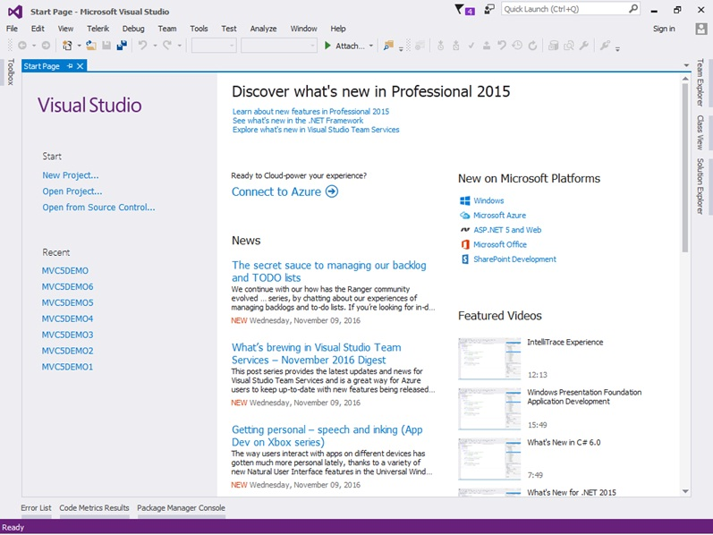

After clicking on "New Project" link a new dialog will pop up.

In that we are going to select web templates from left pane after selecting web template, we find only one project template in it "ASP.NET Web Application" just select that.

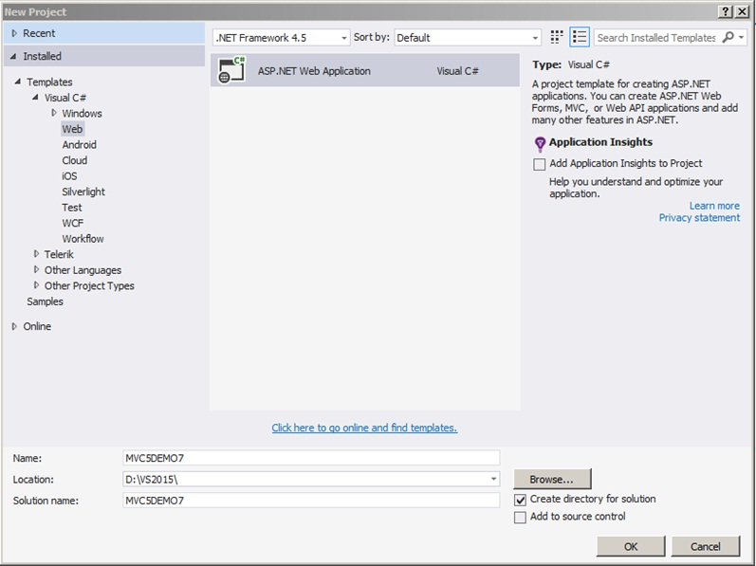

After selecting this project template next we are going to name project as "MVC5DEMO7" and clicking on the OK button a new dialog will pop up with Name "New ASP.NET Project" for selecting project Templates.

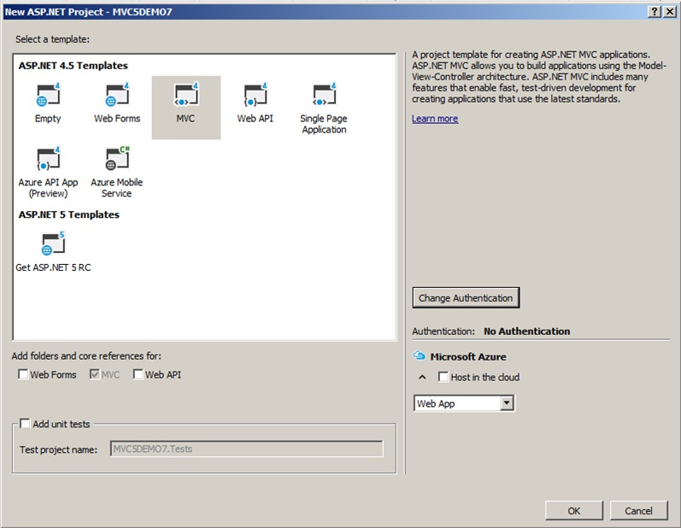

In this dialog we are going to choose MVC project template and then we are going to choose Authentication type for doing that just click on Change Authentication button, a new dialog will pop up with name "Change Authentication" here we are going to choose No Authentication click on OK Button.

It will show progress bar while it is creating project.

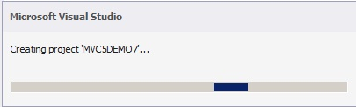

After creating project it will show Readme html page with use links on that page.

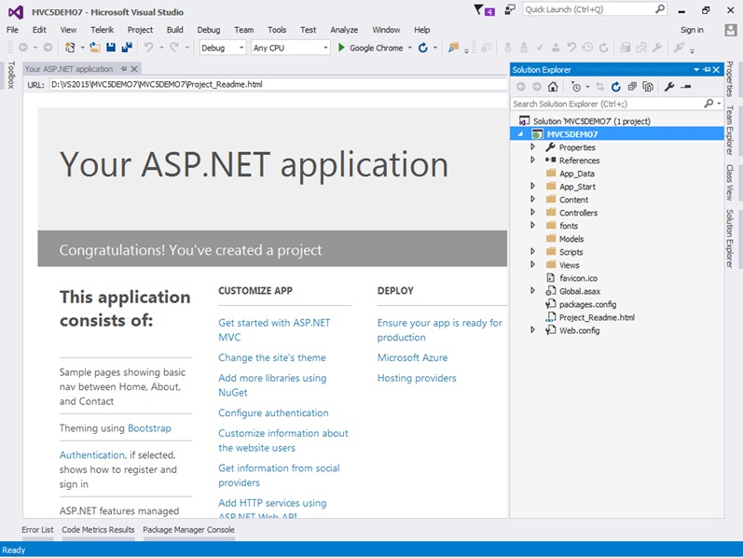

After creating project first thing we are going add Filter folder in Project.

For adding Folder just right click on "MVC5DEMO7" and then select Add ➜ and inside that select "New Folder" and name it as Filters.

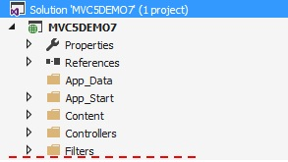

After adding Filters folder the next thing we are going add Authentication Filter in this folder to validate User is Logged in to application or not.

**Adding Authentication Filter**

Let's Add Authentication Filter in for doing that just right click on Filters folder then select Add ➜ and inside that select Class a new dialog will pop up with name Add New Item with default Class template selected.

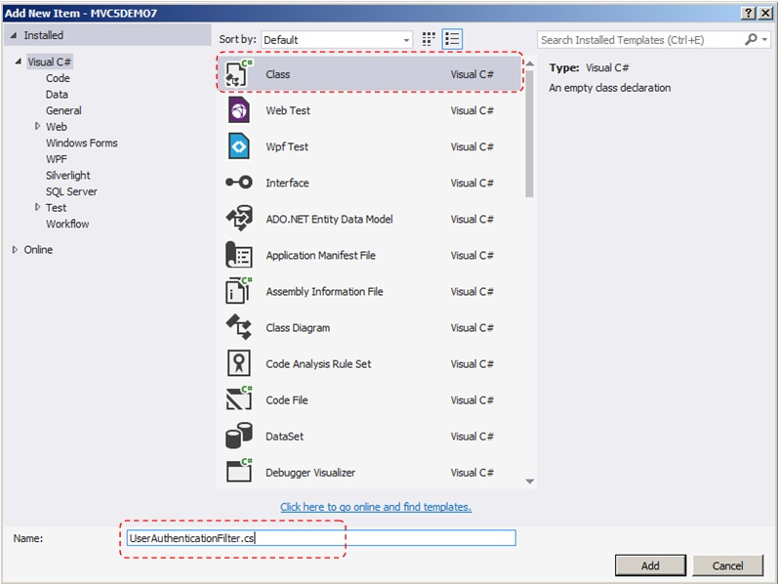

Then we are going to name class as UserAuthenticationFilter and finally click on Add Button.

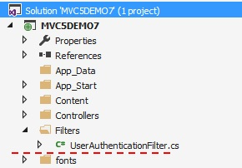

**Below is Code Snippet of UserAuthenticationFilter**

After creating Filter next UserAuthenticationFilter will inherit a class FilterAttribute and IAuthenticationFilter.

And in this filter we are just going to check Session is IsNullOrEmpty if it is NULL or Empty then we are going to set Result to HttpUnauthorizedResult ();

And in OnAuthenticationChallenge method we are going check this result is not null or Result is HttpUnauthorizedResult.

If result is HttpUnauthorizedResult then we are going to redirect it to Error View.

using System;

using System.Collections.Generic;

using System.Linq;

using System.Web;

using System.Web.Mvc;

using System.Web.Mvc.Filters;

namespace MVC5DEMO7.Filters

{

public class UserAuthenticationFilter : ActionFilterAttribute, IAuthenticationFilter

{

public void OnAuthentication(AuthenticationContext filterContext)

{

//Check Session is Empty Then set as Result is HttpUnauthorizedResult

if (string.IsNullOrEmpty(Convert.ToString(filterContext.HttpContext.Session["UserID"])))

{

filterContext.Result = new HttpUnauthorizedResult();

}

}

//Runs after the OnAuthentication method

//------------//

//OnAuthenticationChallenge:- if Method gets called when Authentication or Authorization is

//failed and this method is called after

//Execution of Action Method but before rendering of View

//------------//

public void OnAuthenticationChallenge(AuthenticationChallengeContext filterContext)

{

//We are checking Result is null or Result is HttpUnauthorizedResult

// if yes then we are Redirect to Error View

if (filterContext.Result == null || filterContext.Result is HttpUnauthorizedResult)

{

filterContext.Result = new ViewResult

{

ViewName = "Error"

};

}

}

}

}

After creating UserAuthenticationFilter in next step we are going to create a simple login page.

For doing that we have to create Model for login page right.

**Adding LoginModel**

We have created a Model in Models Folder with Name LoginModel it has 2 properties Username and Password.

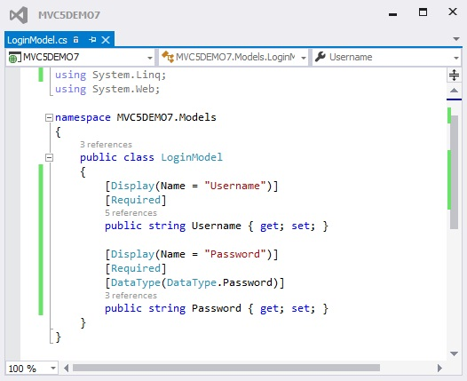

After adding LoginModel in next step we are going to add UserLogin Controller.

**Adding UserLogin Controller**

For adding UserLoginController just right on Controllers folder inside that select Add ➜ inside that select Controller after selecting Controller a new dialog with name "Add Scaffold" will pop up for choosing type of controller to add in that we are just going to select "MVC5Controller - Empty" and click on Add button, after that a new dialog with name "Add Controller" will pop up asking for Controller name here we are going to name controller as UserLoginController and click on Add button.

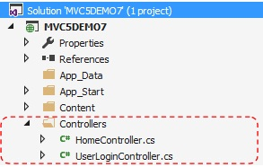

After adding UserLogin Controller in next step we are going to add 2 Action Method one which handles HttpGet Request and other which handle HttpPost Request.

In Post Request we are checking ModelState is valid or not if not then we are return model to View which show error on View.

If it is valid then we are going to check Username and Password is valid or not for this demo I have hardcoded values.

The Username to "Test" and Password to "Test" and if enter Username and Password is equal then we set Session["UserID"] and redirect to Index View of Home Controller.

**See below Snapshot of UserLogin Controller**

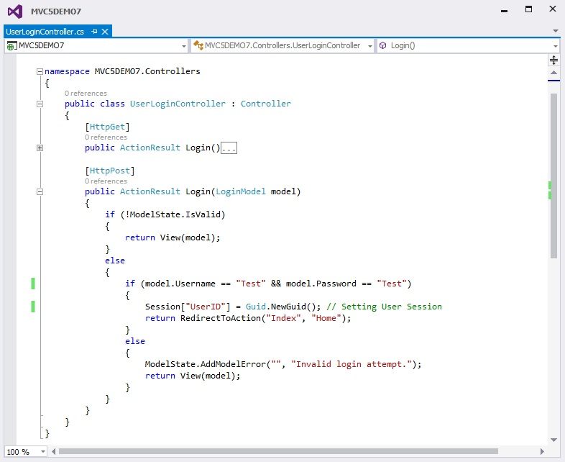

**Note:-** Home controller comes by Default when you create Application.

After adding UserLoginController in next step we are going to add apply UserAuthentication Filter on HomeController.

**Applying UserAuthentication Filter on Home Controller**

In this part we have applied UserAuthentication Filter on Home Controller.

Now if User is logged with valid credentials into application then only will be able to access Home Controller, because we have applied UserAuthentication Filter on Home Controller.

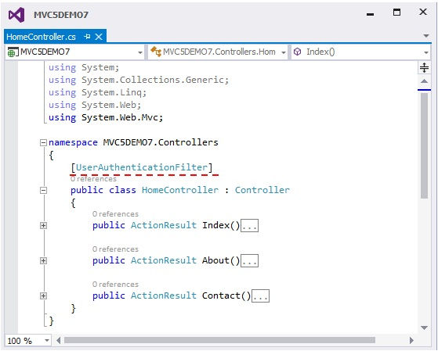

Now let's save this application and run.

Next we are going to access Index Action Method of HomeController.

URL: http://localhost:####/home/index

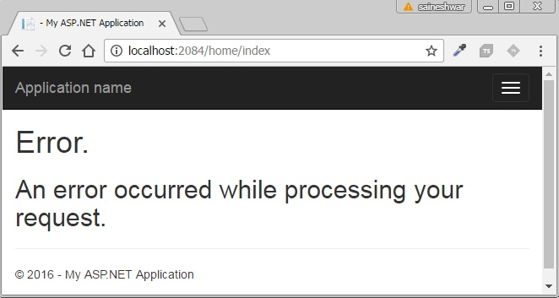

Wow we do not have access to this page it is redirecting to Error View because we have applied UserAuthentication Filter on it.

Next we are going to access Login Action Method of UserLoginController.

URL: http://localhost:####/UserLogin/login

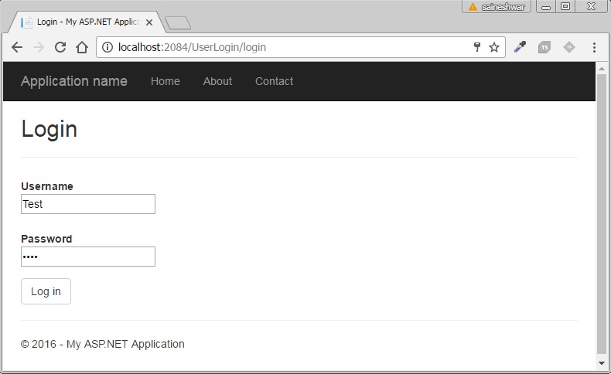

After entering Valid Credentials click on Log in button to Log into Application.

**Debugging of UserAuthentication filter**

Below is debug mode of **UserAuthentication** Filter where you can see real time values and how Authentication filter works.

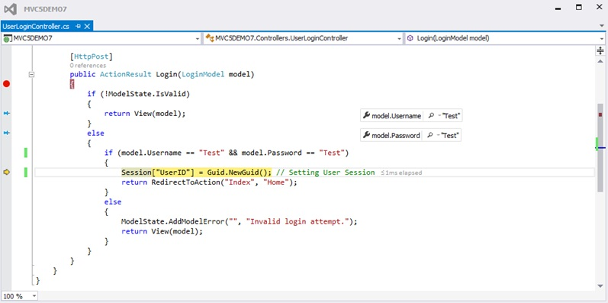

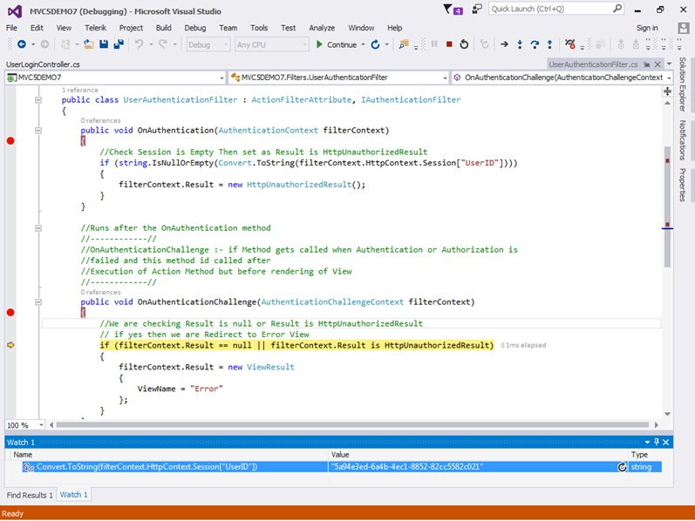

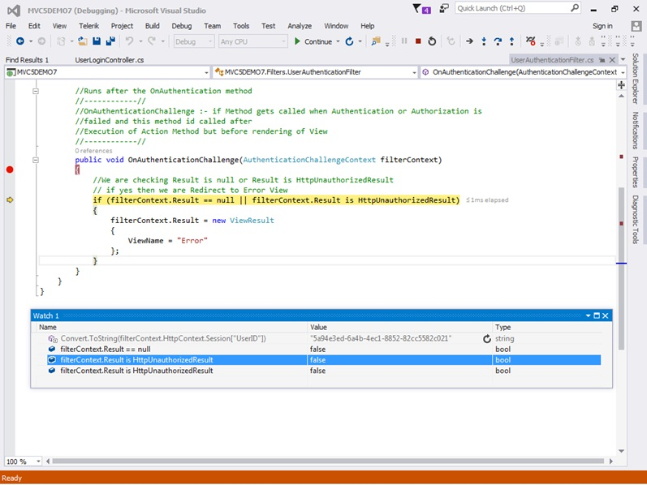

After entering Valid Credentials we have passed Authentication check and we have been redirected to HomeController as show below.

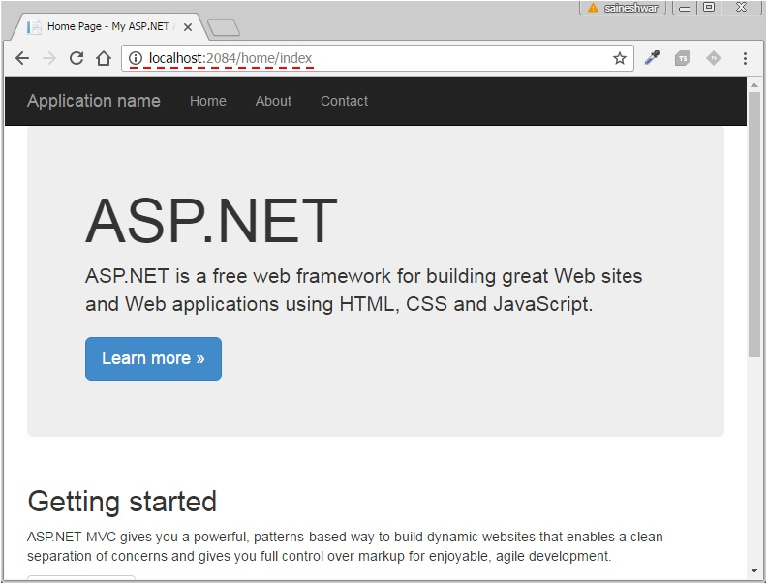

If we enter Invalid Credentials then we cannot Login and if we cannot login then we cannot access Home controller.

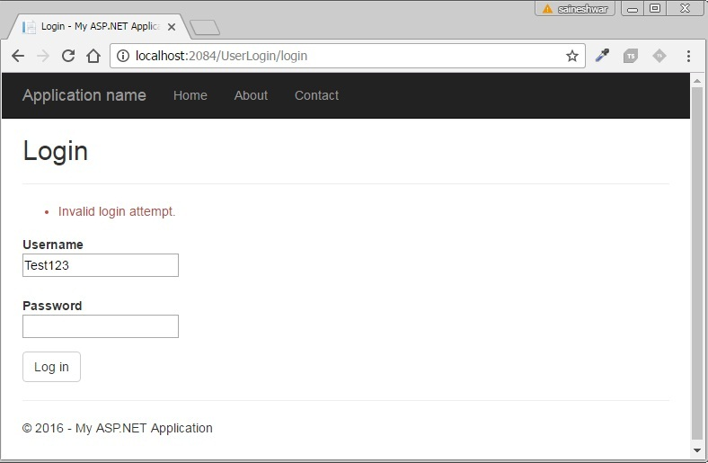

Final we have completed understanding Authentication Filter a New feature in MVC 5 I hope you have enjoyed in this reading this article.